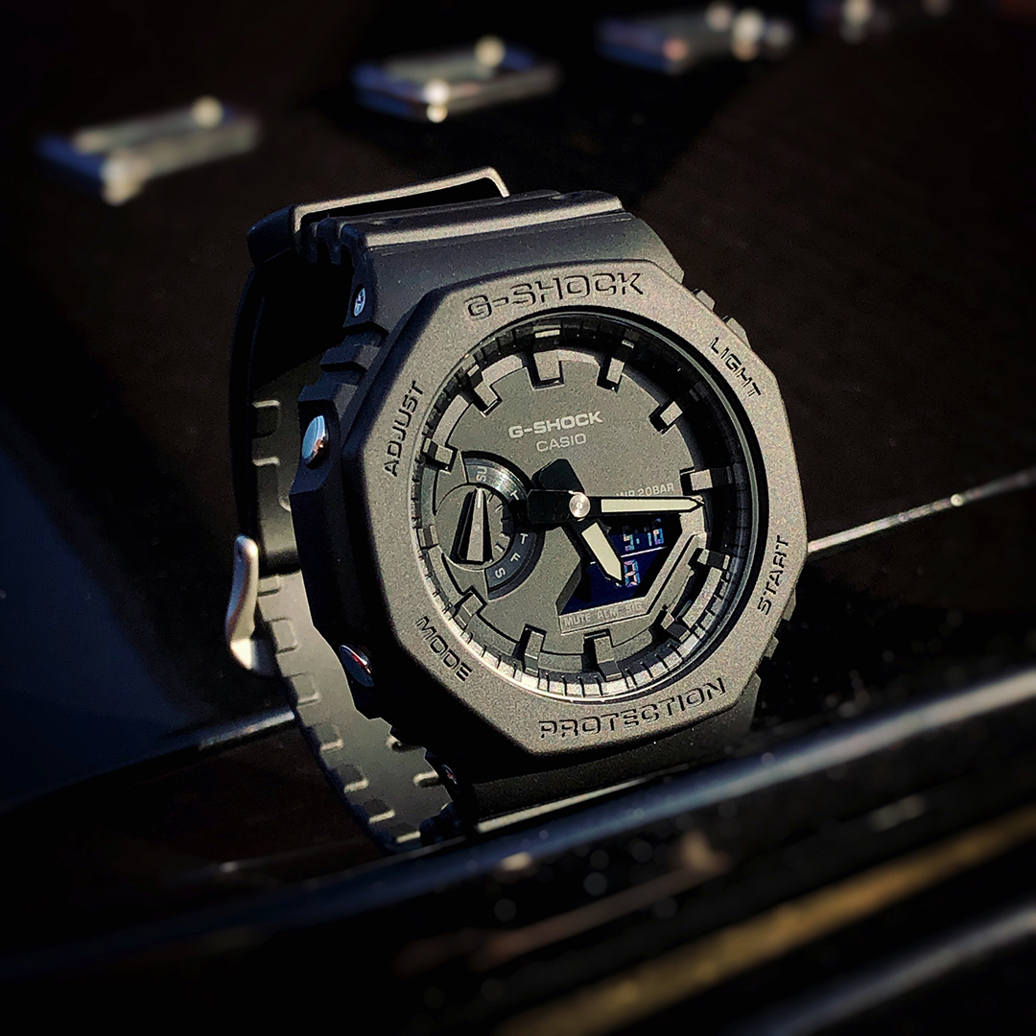Description: The **Casio G-Shock** is one of the toughest and most durable watch series in the world, designed for extreme conditions. First introduced in 1983, G-Shock watches are known for their **shock-resistant structure**, making them ideal for military personnel, athletes, outdoor adventurers, and everyday wear. These watches feature **water resistance (often up to 200 meters), stopwatch, countdown timer, alarms, and LED backlight** for visibility in low-light conditions. Some advanced models also include **solar charging, Bluetooth connectivity, and GPS tracking**. With their rugged design, long-lasting battery, and unbeatable toughness, G-Shock watches are perfect for those who need a watch that can withstand the harshest environments.